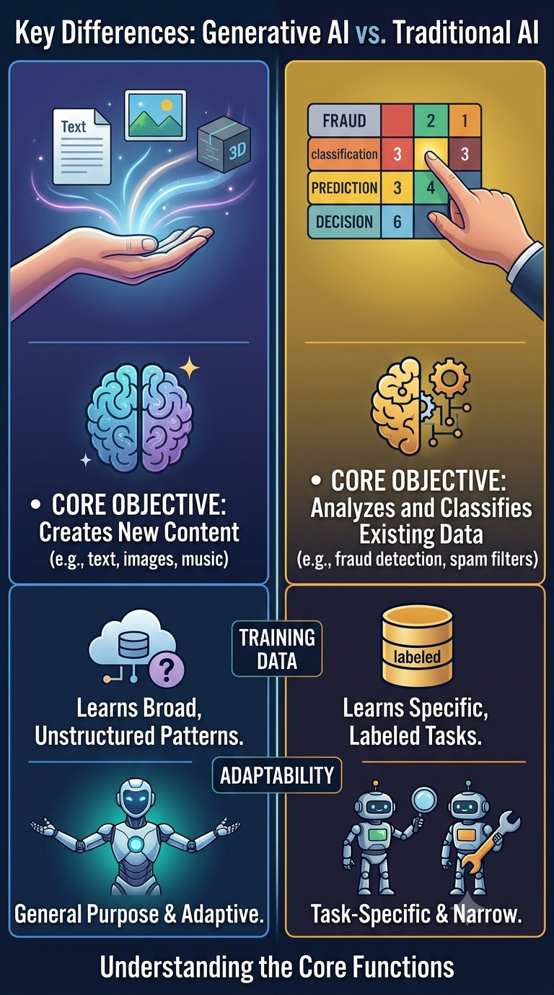
🌟 Generative AI: The Technology That Moved AI From Thinking to Creating
For years, Artificial Intelligence was primarily focused on analyzing data, identifying patterns, making predictions and automating decisions. Today, we are witnessing a major shift in technology.
Generative AI has changed the game.
Instead of simply answering questions about existing information, it can create entirely new content, generate ideas, write code, design images, summarize knowledge, produce videos, assist with research, and even collaborate with humans on complex tasks.
📊 Traditional AI / Machine Learning
✅ Analyze Data
✅ Detect Patterns
✅ Make Predictions
✅ Classify Information
✅ Forecast Outcomes
Examples:
• Fraud Detection
• Recommendation Systems
• Spam Filtering
• Sales Forecasting
✨ Generative AI
✅ Generate Text
✅ Create Images
✅ Write Code
✅ Produce Videos
✅ Generate Audio
✅ Design Content
✅ Reason & Assist

Examples:
• ChatGPT
• DALL·E
• GitHub Copilot
• Gemini
• Claude
• Midjourney
The difference is simple:
Traditional AI helps us understand data.
Generative AI helps us create something entirely new from that data.
🚀 Why Generative AI Is Creating So Much Excitement
Imagine having:
📝 A writer available 24/7
🎨 A graphic designer on demand
💻 A coding assistant that never sleeps
📊 A data analyst that explains insights instantly
🎓 A personal tutor that adapts to your learning style
📚 A research assistant that summarizes complex information in seconds
This is exactly why Generative AI has become one of the fastest-adopted technologies in history.
👨‍💻 The Rise of the AI-Augmented Professional
Every profession is evolving.
Traditional Worker + Generative AI = AI-Augmented Professional
Tomorrow's professionals will not necessarily be those who know the most. They will be those who know how to:
✅ Ask better questions
✅ Use AI effectively
✅ Validate AI outputs
✅ Automate repetitive tasks
✅ Focus on creativity and strategic thinking
🔌 Democratization of AI Through APIs
One of the biggest reasons behind the rapid adoption of Generative AI is accessibility.
In the past:
Need Powerful AI?
├── Expensive Hardware
├── Massive Datasets
├── Large AI Teams
├── Research Expertise
└── Significant Budget
Today:
🌐 AI API + 💻 Laptop + 🌎 Internet = 🚀 AI Application
Developers and businesses can integrate advanced AI capabilities using simple APIs without training large models from scratch.
This has dramatically lowered the barrier to innovation.
🧩 Opportunities Created by Generative AI
🌟 Content Creation
🌟 Software Development
🌟 Customer Service
🌟 Research & Analysis
🌟 Education
🌟 Healthcare
🌟 Marketing
🌟 Business Automation
🌟 Digital Transformation
🌟 Entrepreneurship
Every major technological wave creates new opportunities.
Generative AI is creating entirely new categories of products, services, and career paths.
⚖️ The Responsibility Side of AI
While opportunities are enormous, responsible adoption is equally important.
Organizations must address:
✅ Data Privacy
✅ Security Risks
✅ Regulatory Requirements
✅ AI Bias
✅ Explainability
✅ Responsible Governance
✅ Human Oversight
Building trustworthy AI will become just as important as building powerful AI.
Generative AI is much more than a technology trend.
It represents a fundamental shift in how humans interact with software, knowledge, and creativity.
The best strategy is simple:
Learn continuously. Build consistently. Adapt quickly.
Because the future belongs not only to those who use AI, but to those who understand how to collaborate with it effectively. 🚀

